**Create Partitions**

In this demo, you create partitions to divide the FactInternetSales table into smaller logical parts that can be processed (refreshed) independent of other partitions. By default, every table you include in your model has one partition, which includes all the table’s columns and rows. For the FactInternetSales table, we want to divide the data by year; one partition for each of the table’s five years. Each partition can then be processed independently.

## **Creating partitions**

1. In Tabular Model Explorer, expand **Tables**, and then right-click **FactInternetSales** > **Partitions**.

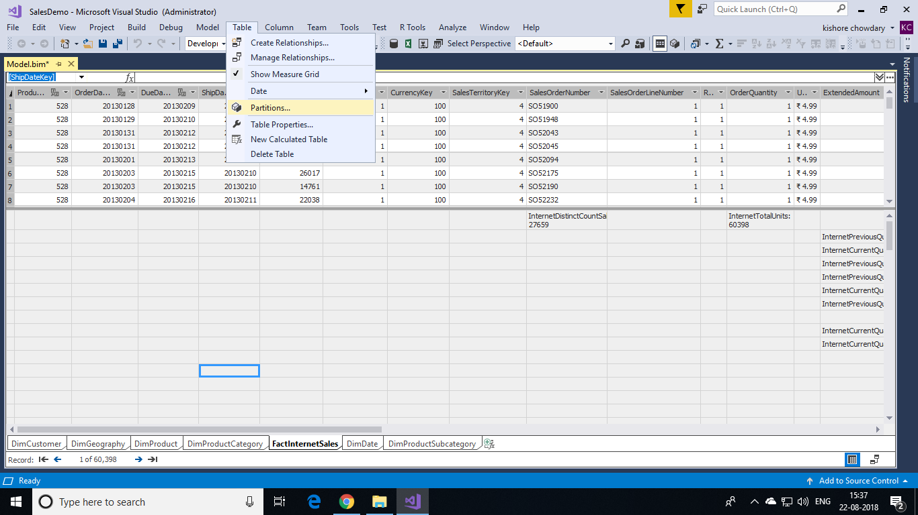

1. In Partition Manager, click **Copy**, and then change the name to **FactInternetSales2013**.

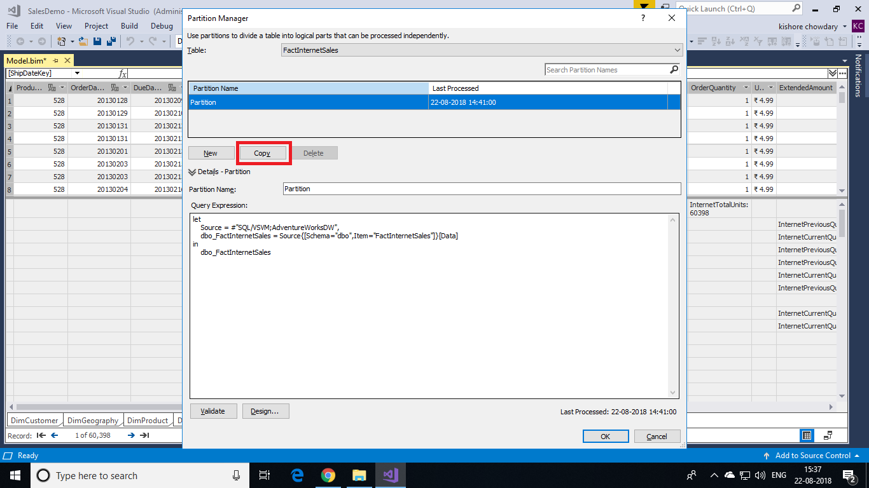

Because you want the partition to include only those rows within a certain period, for the year 2013, you must modify the query expression.

1. Click **Design** to open Query Editor, and then click the **FactInternetSales2013** query.

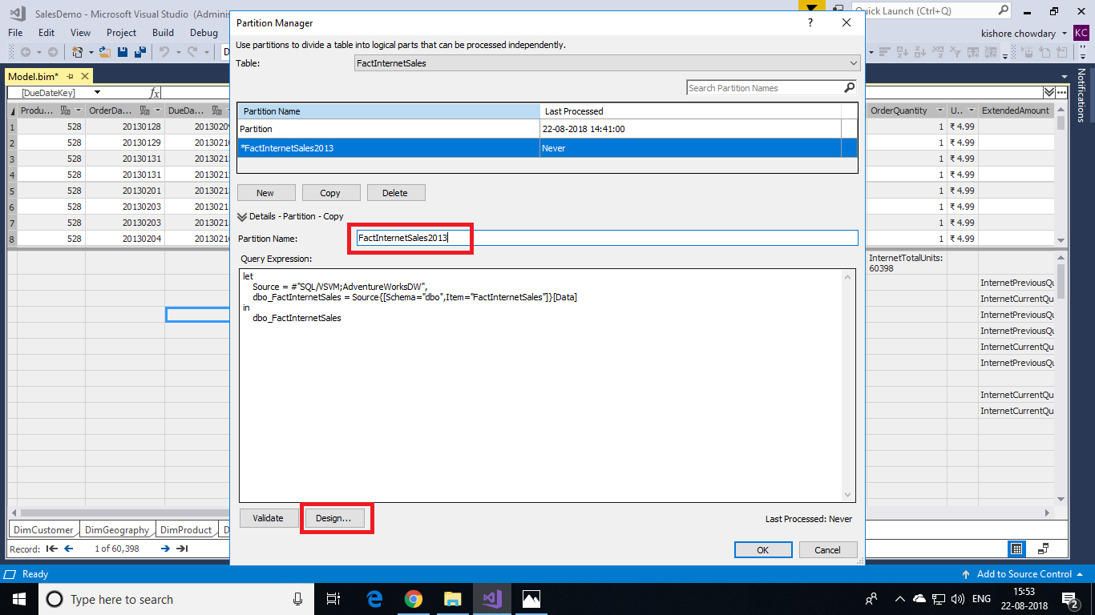

1. In preview, click the down arrow in the **OrderDate** column heading, and then click **Date/Time Filters** > **Between**.

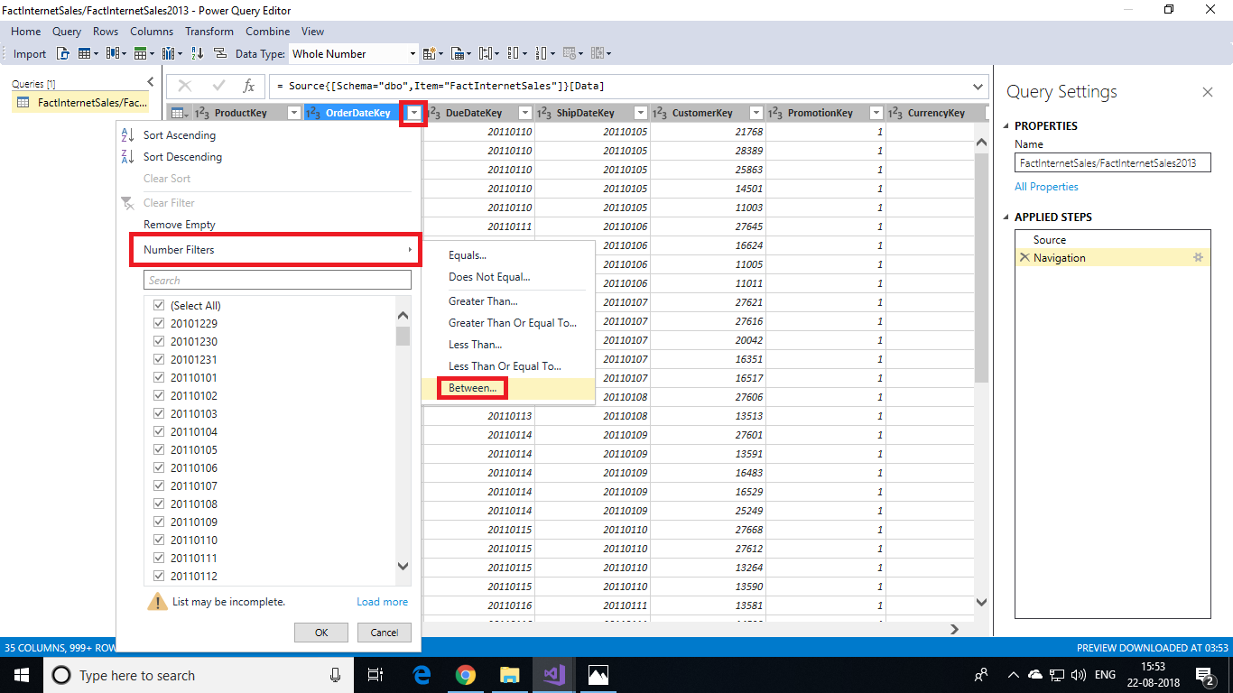

1. In the Filter Rows dialog box, in **Show rows where: OrderDate**, leave **is after or equal to**, and then in the date field, enter **20101229**. Leave the **And** operator selected, then select **is before**, then in the date field, enter **20120317**, and then click **OK**.

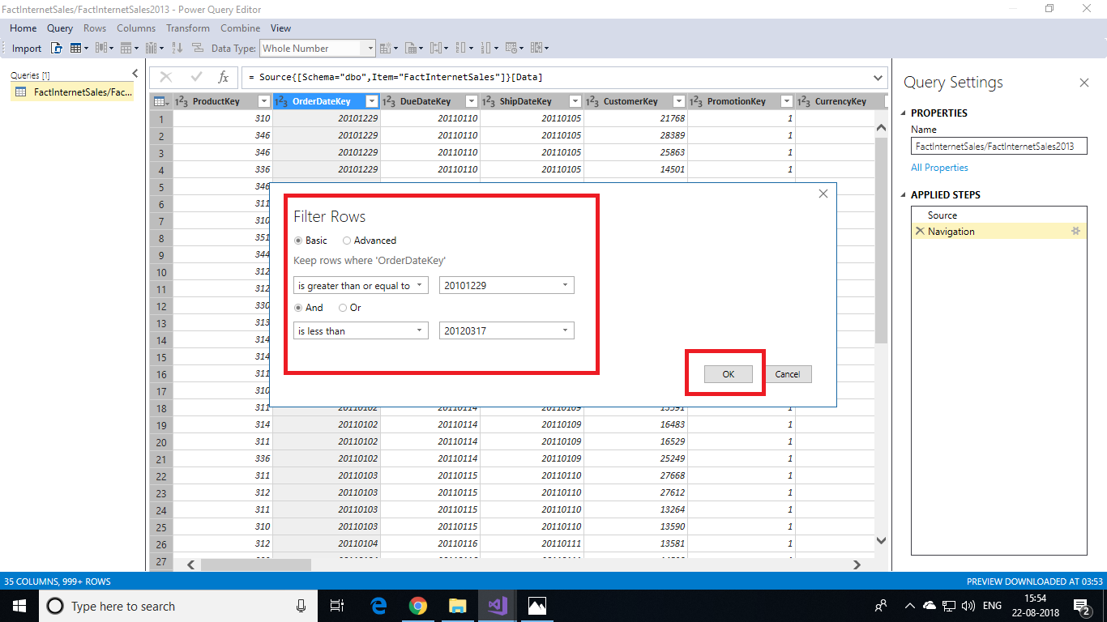

Notice in Query Editor, in APPLIED STEPS, you see another step named Filtered Rows. This filter is to select only order dates from 2013.

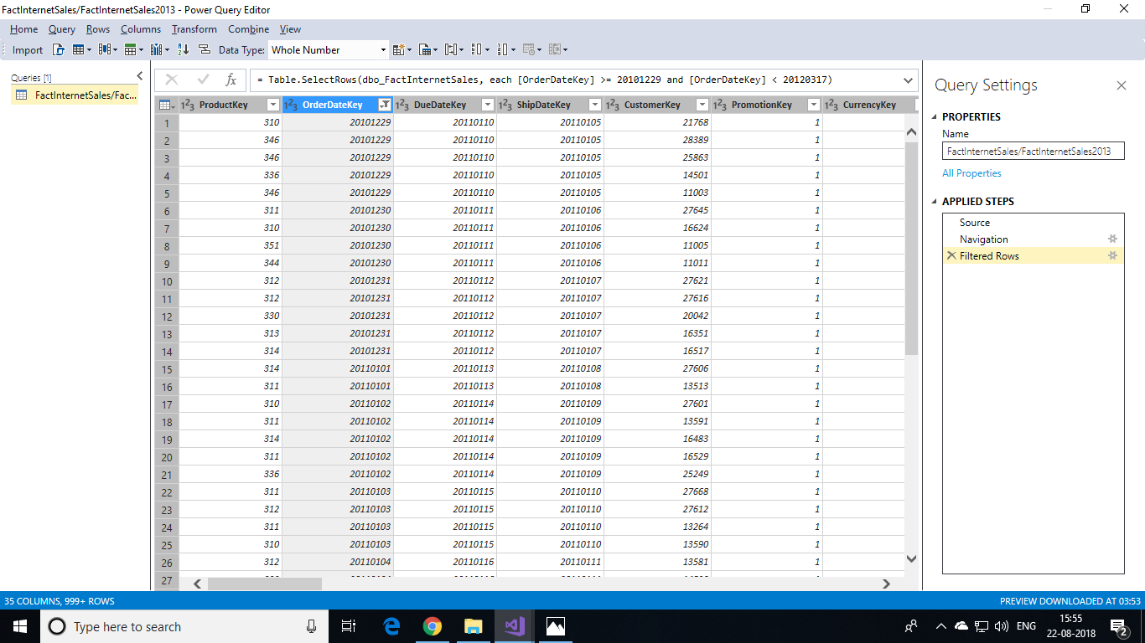

1. Click **Import**.

In Partition Manager, notice the query expression now has an additional Filtered Rows clause.

